Operating systems   
Lab 4 - Report  
Short-term Scheduling Policies

Nikolay Stoitsov

Adriana Bostandzhieva

Table of Contents

Short-term Scheduling Policies 2

Description 2

Solution and Results 2

## Short-term Scheduling Policies

## Description

The aim of the task is to implement and analyse the performance of 6 different scheduling policy algorithms in an operating system – Random, First Come First Served, Short Process Next, Short Remaining Time, HRRN and Round Robin with different time slices q.

## Solution and Results

The classes are implemented and tested with 1000 processes. The final output of every algorithm is similar to the one shown on Fig. 1. That is the average of Service time, MTBBB and Turnaround for every of the 25 groups. The quotient is the ratio between the Turnaround and Service time. The quotients for all the policies are plotted on Fig. 2.

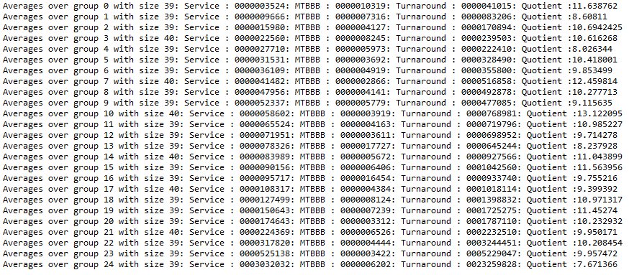

Figure . Random scheduling policy

Figure 2. Short-term scheduling policies